GROUP-4

Task_4 :To imbibe the lighthouse in Dining module of Urbanladder.com

(a) LIGHTHOUSE

Google Lighthouse is an open-source, automated tool for measuring the quality of web pages. It can be run against any web page, public or requiring authentication. Google Lighthouse audits performance, accessibility and search engine optimization of web pages

1) After adding Lighthouse to Google chrome extension, inspect the webpage of Dining in Urbanladder.com
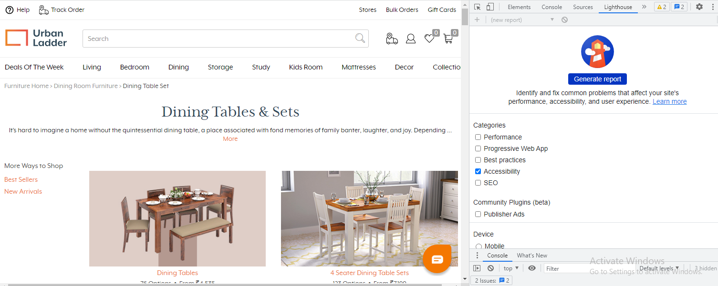
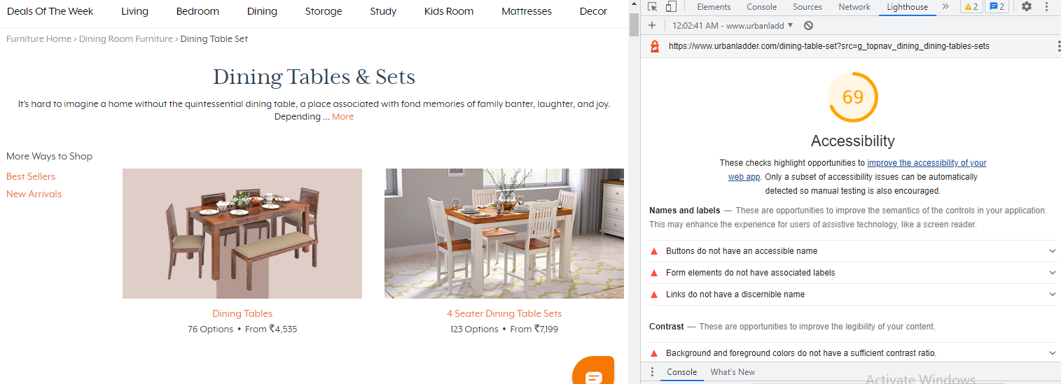
2) Click on 'Generate Report' for finding the accessibility of Dining module in Urban ladder website.

(b) Google Axe Tool

The Google Axe Tool browser extension is ideal for development teams to test your web applications to help identify and resolve common accessibility issues.

It’s simple to use, doesn’t require advanced accessibility knowledge and won’t waste your time with false positives.

